Collective Numerals

✅ Definition:
# Source: AI Source: Provided by: [Data Path: Persons Table -> ID Column: 1, Name_En Column: Motasem Essam] -> From: [Chatgpt (GPT-4-turbo)] on [7/28/2025]
Collective numerals refer to groups or sets of things or people treated as a unit.
They express a whole group of counted elements, often without listing the individual units.
They answer:
- "How many in a group?"
- "What unit of collection?"

🧩 Common Collective Numerals:
# Source: AI Source: Provided by: [Data Path: Persons Table -> ID Column: 1, Name_En Column: Motasem Essam] -> From: [Chatgpt (GPT-4-turbo)] on [7/28/2025]
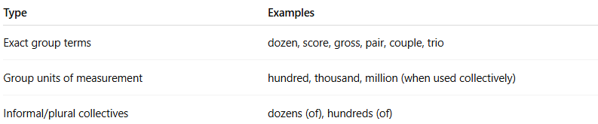
Type | Examples
Exact group terms | dozen, score, gross, pair, couple, trio
Group units of measurement | hundred, thousand, million (when used collectively)
Informal/plural collectives | dozens (of), hundreds (of)

✏️ Examples in Sentences:
# Source: AI Source: Provided by: [Data Path: Persons Table -> ID Column: 1, Name_En Column: Motasem Essam] -> From: [Chatgpt (GPT-4-turbo)] on [7/28/2025]
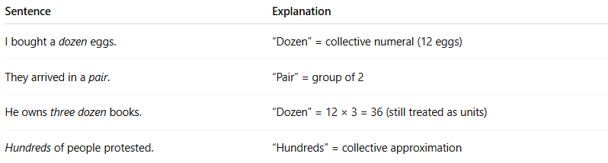
Sentence | Explanation
I bought a dozen eggs. | “Dozen” = collective numeral (12 eggs)
They arrived in a pair. | “Pair” = group of 2
He owns three dozen books. | “Dozen” = 12 × 3 = 36 (still treated as units)
Hundreds of people protested. | “Hundreds” = collective approximation

📌 Grammatical Functions:
# Source: AI Source: Provided by: [Data Path: Persons Table -> ID Column: 1, Name_En Column: Motasem Essam] -> From: [Chatgpt (GPT-4-turbo)] on [7/28/2025]
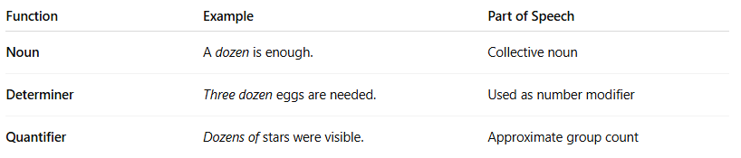
Function | Example | Part of Speech
Noun | A dozen is enough. | Collective noun
Determiner | Three dozen eggs are needed. | Used as number modifier
Quantifier | Dozens of stars were visible. | Approximate group count

🔍 Properties of Collective Numerals:
# Source: AI Source: Provided by: [Data Path: Persons Table -> ID Column: 1, Name_En Column: Motasem Essam] -> From: [Chatgpt (GPT-4-turbo)] on [7/28/2025]
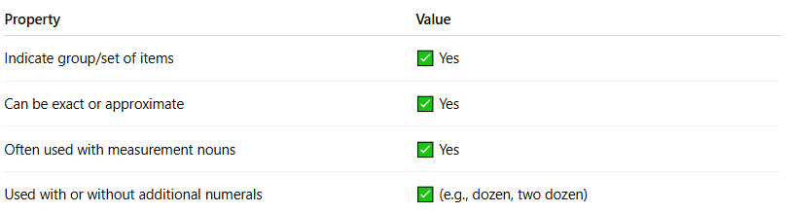
Property | Value
Indicate group/set of items | ✅ Yes
Can be exact or approximate | ✅ Yes
Often used with measurement nouns | ✅ Yes
Used with or without additional numerals | ✅ (e.g., dozen, two dozen)

⚠️ Note:
# Source: AI Source: Provided by: [Data Path: Persons Table -> ID Column: 1, Name_En Column: Motasem Essam] -> From: [Chatgpt (GPT-4-turbo)] on [7/28/2025]
- Collective ≠ Cardinal:
  - Three = just 3
  - A dozen = 12 treated as one unit
- Collective numerals behave like mass or unit counters.
- Some collective numerals are fixed (dozen = 12), others are generalized (hundreds = many groups of 100).

🧠 Summary:
# Source: AI Source: Provided by: [Data Path: Persons Table -> ID Column: 1, Name_En Column: Motasem Essam] -> From: [Chatgpt (GPT-4-turbo)] on [7/28/2025]
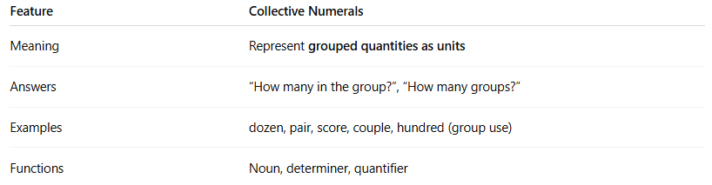
Feature | Collective Numerals
Meaning | Represent grouped quantities as units
Answers | “How many in the group?”, “How many groups?”
Examples | dozen, pair, score, couple, hundred (group use)
Functions | Noun, determiner, quantifier

